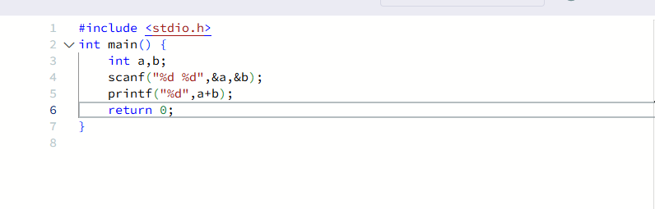
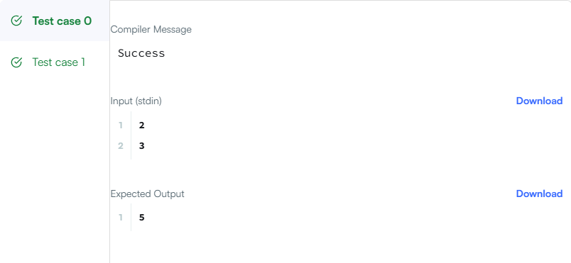

CODE-

#include <stdio.h>
int main() {
int a,b;
scanf("%d %d",&a,&b);
printf("%d",a+b);
return 0;
}

LINK-

https://www.hackerrank.com/challenges/solve-me-first/problem

